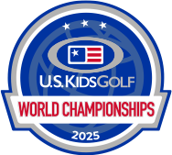

Skills Challenge WINNERS:

**Chip On’s: Jackson Wang** - **Boys 13**

**Closest to the Pin: Ellie West** - **Girls 13**

**Skeeball: Neil Langford** – **Boys 13**

**Lob Wall: Zack Kinzer** – **Boys 14**